GANESH M
192524034

Experiment 5: Cloud-Based Library Book Reservation System for SIMATS Library (SaaS)
AIM:
To create a simple cloud software application for the Library Book Reservation System of SIMATS Library using a Cloud Service Provider to demonstrate the Software as a Service (SaaS) model.
PROCEDURE:
- Sign in to the Cloud Service Provider platform and create a new application named SIMATS Library.
- Create the Books form and add the fields: Title of the book, Author, Publications, Year, Edition, No. of copies, Rack no, and Status (Taken/Returned).
- Configure the Status field as a dropdown with values Available, Taken, and Returned.
- Save the form and enter sample book records to test the application.
- Verify that book records can be searched by title, author, and rack number.
- Publish the application and access it through a web browser to demonstrate SaaS.
SCREENSHOT:
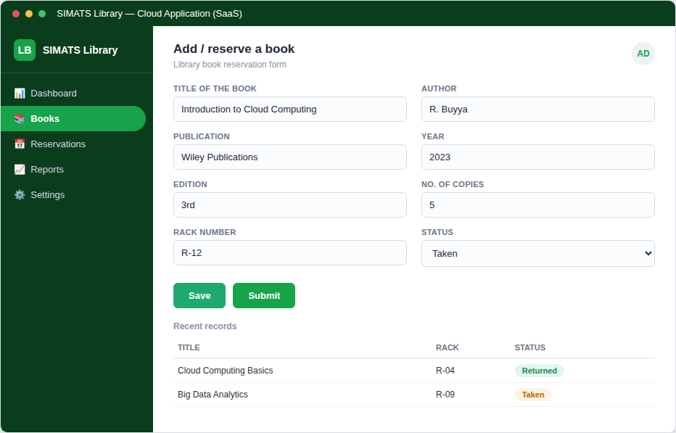
Figure 5: Library book reservation form and record list on the cloud application.
RESULT:
A cloud-based Library Book Reservation System for SIMATS Library was successfully created. The application captured all required book fields correctly and was accessible through a web browser, demonstrating the Software as a Service (SaaS) model.

